Unmanaged Switch

🟦 What is an Unmanaged Switch?
# Source: Chatgpt (GPT‑5 Mini) at [12/18/2025]
An Unmanaged Switch is a basic, plug-and-play network device used to connect multiple devices (like computers, printers, IP cameras) on a Local Area Network (LAN) — without any configuration.
It’s designed for simplicity and ease of use, commonly used in homes, small offices, or non-technical environments.

🔧 Key Features of an Unmanaged Switch
# Source: Chatgpt (GPT‑5 Mini) at [12/18/2025]
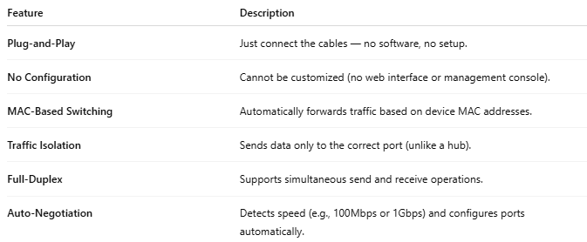

Feature | Description
Plug-and-Play | Just connect the cables — no software, no setup.
No Configuration | Cannot be customized (no web interface or management console).
MAC-Based Switching | Automatically forwards traffic based on device MAC addresses.
Traffic Isolation | Sends data only to the correct port (unlike a hub).
Full-Duplex | Supports simultaneous send and receive operations.
Auto-Negotiation | Detects speed (e.g., 100Mbps or 1Gbps) and configures ports automatically.

🏠 Example Use: Small Office/Home LAN
# Source: Chatgpt (GPT‑5 Mini) at [12/18/2025]
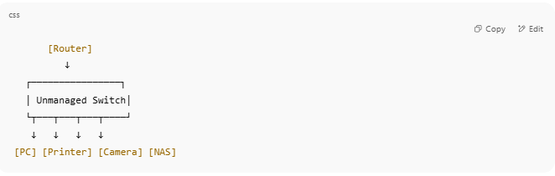

[Router]
↓
┌────────────────┐
│ Unmanaged Switch│
└┬───┬───┬───┬────┘
↓ ↓ ↓ ↓
[PC] [Printer] [Camera] [NAS]

No need for settings — devices are connected instantly and can communicate.

🆚 Managed vs Unmanaged Switch
# Source: Chatgpt (GPT‑5 Mini) at [12/18/2025]
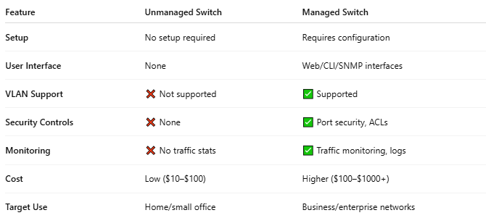

Feature | Unmanaged Switch | Managed Switch
Setup | No setup required | Requires configuration
User Interface | None | Web/CLI/SNMP interfaces
VLAN Support | ❌ Not supported | ✅ Supported
Security Controls | ❌ None | ✅ Port security, ACLs
Monitoring | ❌ No traffic stats | ✅ Traffic monitoring, logs
Cost | Low ($10–$100) | Higher ($100–$1000+)
Target Use | Home/small office | Business/enterprise networks

✅ Advantages
# Source: Chatgpt (GPT‑5 Mini) at [12/18/2025]

- Very easy to use
- Affordable
- Reliable for simple needs
- Energy-efficient (most models auto-disable unused ports)

❌ Limitations
# Source: Chatgpt (GPT‑5 Mini) at [12/18/2025]

- No customization or control
- No VLANs or QoS (Quality of Service)
- Not suitable for complex or secure networks

